# **Task 1**

Basics thing I noted before finding insights:

* First Thing I noted is ‘Date’ Feature is not in Correct Format so I changed by using to_datatime()method.
* There is no null values and outliers in the dataset
* Then I converted data as an index
* This all are the basics things I done before Visualization

EDA :

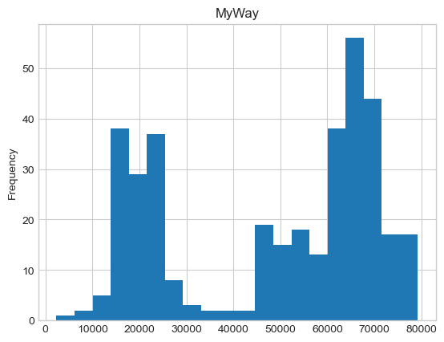UNIVARIATE Analysis:(MyWay Feature):

Insights:

* First Thing I noted both Features Having **Normal Distribution**
* And there is a high Frequency in the range 60000-70000 passengers for MyWay Feature,because of **Seasonality or Noice**.
* Both feature having **no null values and no Outliers**

UNIVARIATE Analysis:( Paper Ticket Feature): 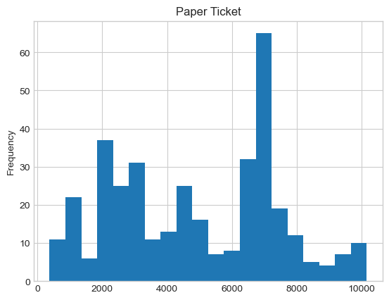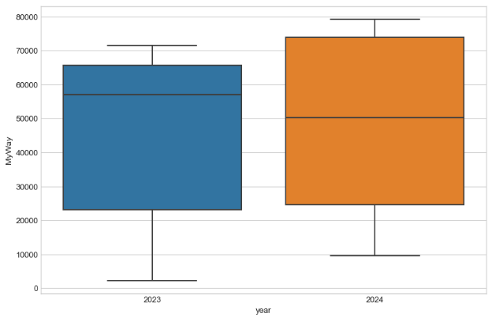

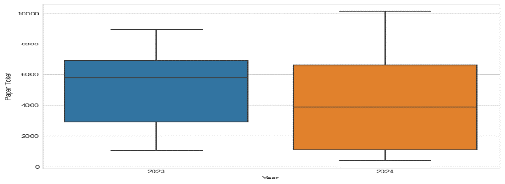

**BIVARIATE ANALYSIS:(Myway and Paper Ticket feature)**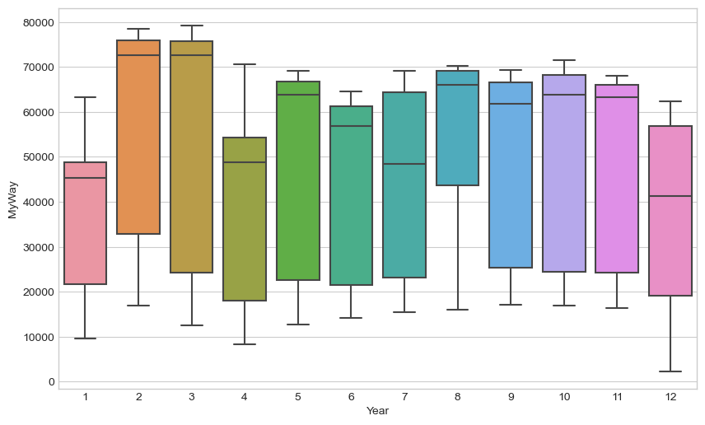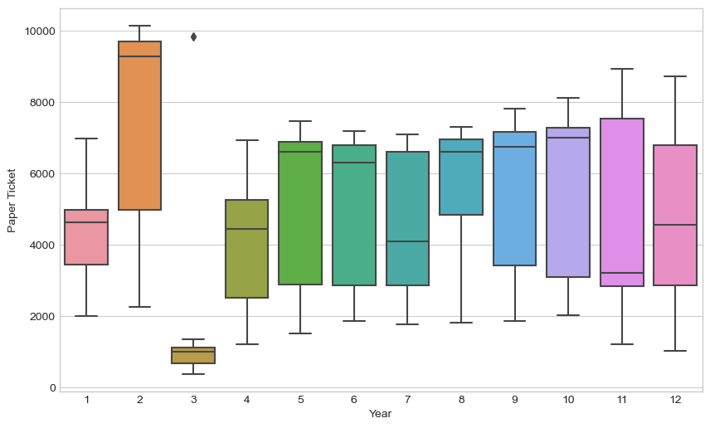

**Insights:**

* Median value across years confirm **an upwards and Downwards trends in Myway and Paper Ticket count**
* Steady increase in **the spread or IQR range increasing steadily across yea**rs.
* **25% of the Myway** type used by the **23244 passenger**s, **50% of the Myway type** used by the **56587 passenger** and **75% of the Myway type** **used by the 66453 passenger**.
* **25% of the Paper Ticket** Type **used by the 2649 passengers,50% of the Paper Ticket** Type used by **4850 passenger and 75% of the Paper Tickert Typ**e used by the **6939 passenger.**

**Stationarity checking:**

* I used **Augmented Dickey Fuller** technique to **find wheather it is stationary or not stationary**
* Based on the Dickey-Fuller test results, **the ADF Statistic is -0.9335405980757765 and the p-value is 0.7767264880824922**. Comparing the ADF Statistic to the critical values, we can see **that it is greater than the 1%, 5%, and 10% critical values**. This means that **we fail to reject the null hypothesis that the data is non-stationary**. Therefore, the data is considered **non-stationary**.
* Comparing 2023,The passengers count more in **Myway and Paper Ticket Type in 2024**